MTF Research Summary
John N. Rogers, III, Ryan Bearss, Jackie Guevara, and Evan Rogers
Michigan State University
January 2026

Research background: Since initiating the FIFA World Cup 2026 research program in 2022, our work primarily focused on the establishment of sod on plastic (SOP), including both stabilized and non-stabilized systems. In 2025, this body of work was largely completed, and emphasis transitioned to post-installation management.

Study #4: Post-installation hygiene strategies for management of hybrid carpet-mat systems

The objective of this experiment was to assess whether aggressive post-installation hygiene strategies can reduce excessive organic matter in a carpet-mat–stabilized turf system without compromising performance or turf quality. The experiment was conducted in fall 2025. HERO 127.127–stabilized Kentucky bluegrass (Poa pratensis L.) sod was harvested from Green Valley Sod Co. (Littleton, CO) and installed over a shallow-profile system at the Hancock Turfgrass Research Center. Plots were subjected to hygiene cultivation treatments including: no cultivation, 4.5% core aeration, 9% core aeration, 14% vertical mowing (−3 mm), 14% vertical mowing applied twice (−2 mm), 4.5% core aeration combined with 14% vertical mowing, and 9% core aeration combined with 14% vertical mowing. Treatments were applied twice with a 2-wk recovery period between each event. Plots were left to recover for 3 d following each cultivation event and prior to evaluation.

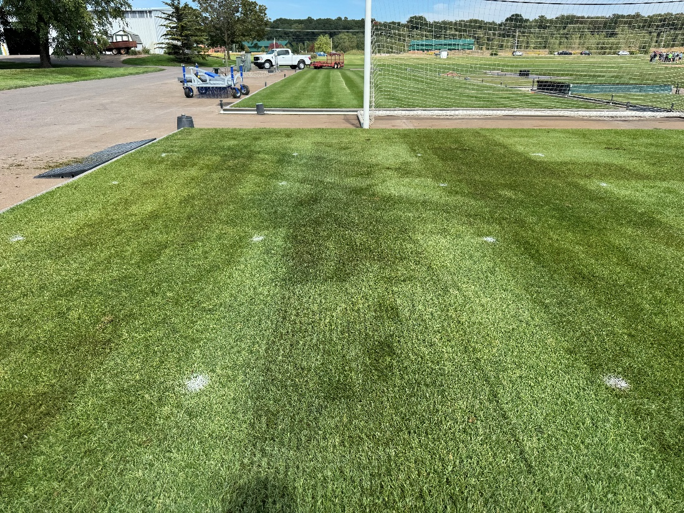
Figure 4. Treatments shortly following the first cultivation event after cores and surface litter were removed (East Lansing, MI-2025).
Key findings:
- Aggressive hygiene treatments (38 × 38 mm core aeration × vertical mowing and vertical mowing applied twice) caused significant short-term turf cover loss and failed to fully recover (<90%).
- A second cultivation event equalized organic matter across treatments, reducing all to acceptable levels (<4%), whereas initial single-pass 38 × 75 mm core aeration and single-pass vertical mowing did not outperform the non-cultivated control.
- Performance metrics were largely unaffected by hygiene strategy: all treatments achieved acceptable surface hardness after recovery, met pitch ball rebound standards, and showed no meaningful differences in fLEX or traction-related parameters.

